**Monte Carlo Simulation: Mosquito finds a host**

**Name: Siddhant Arya**

**Email:** [siddhantarya0707@gmail.com](mailto:siddhantarya0707@gmail.com)

LinkedIn: <https://www.linkedin.com/in/siddhantarya07>

**Problem Statement:**

A mosquito is born in a puddle at [0,0]. She will live for ten days.

At the beginning of each day, she will try to smell a host.

1. If she can smell a host, she will find them, game over.
2. If she cannot, she will “turn off” her sense of smell for the rest of the day and fly 250 m in a random direction. Next morning, GOTO ‘1’.

Obviously, after ten days, if she does not find a host, she dies without taking a blood meal.

A mosquito can smell a human at 50 meters.

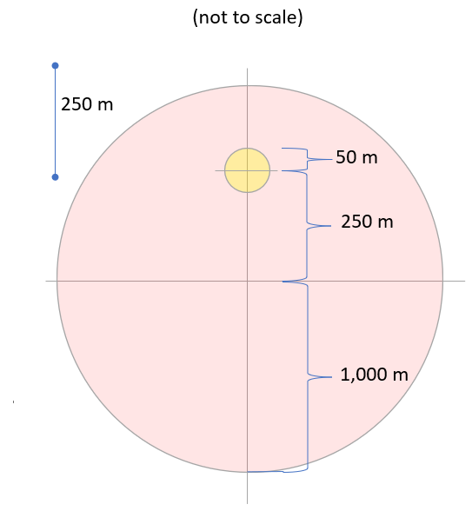

**Algorithms Explained:**

**Case 1 – Mosquito finds a host within 10 days**

Day 1: Mosquito is born, she cannot smell a host; she flies 250 m in a random direction.

Day 2: Mosquito cannot smell a host; she flies 250 m in a random direction.

Day 3: Mosquito cannot smell a host; she flies 250 m in a random direction.

Day 4: When she wakes up on Day four, she finds the host.

**Case 2 - Mosquito is not able to find a host within 10 days**

Day 1: Mosquito is born, she cannot smell a host; she flies 250 m in a random direction.

Day 2: Mosquito cannot smell a host; she flies 250 m in a random direction.

Day 3: Mosquito cannot smell a host; she flies 250 m in a random direction.

……..

……..

……..

Day 10: When she wakes up, she does not find the host and dies.

**Approach:**

**1. Naïve Approach (Initial Guess)**

Since the area of the host circle is = 3.14 * 50*50 = 7850

Area of the bigger circle (Red Region) = 3.14 * 1000 *1000 = 3140000

**So, the Probability of finding the host = the area of the host circle/ are of the bigger circle**

**= 7850 / 3140000 = 0.0025**

**2. Monte Carlo Simulation**

**An Overview**

Monte Carlo simulations are used to model the probability of different outcomes in a process that cannot easily be predicted due to the intervention of **random variables**. It is a technique used to understand the impact of risk and uncertainty in prediction and forecasting models.

The basis of a Monte Carlo simulation involves assigning multiple values to an uncertain variable to achieve multiple results and then averaging the results to obtain an estimate.

We will use Monte Carlo Simulation in our problem statement to find the various random probabilities.

We will first **analyze the movements** **of the mosquito** based on the problem statement.

1. Mosquito starts from the origin (0,0)
2. We calculate a random theta value and then we use the calculated theta value to find x_step taken and y_step taken.
3. We will check if the calculated (x_step, y_step) is in the host region.
4. If Mosquito is able to find the host region, then return True
5. If the Mosquito is outside the red region, return the value of the x which will be used to calculate the probability of the mosquito outside the red region.
6. Else, continue the next day till 10 days and still not found then return False.

We will now Simulate the steps by running the above algorithm running a lot of times. This number generally tends to infinity to get accurate results. The accuracy of results is directly proportional to the higher the number of simulations done.

1. If the result is True, then the Mosquito finds the hosts. We sum up all such results.
2. If the result is False, the mosquito is not able to find the host and hence the number gives the events of the failure in N sampling.
3. After 10 days we send the x and y values. If any of the x and y values are greater than 1000, it means the mosquito is outside the red region and hence after 10 days it will die outside the red region. We also need this number for our statistics.

**Calculating Probabilities:**

The **probability that the mosquito finds the host before she dies is** =

Total Success of Events / Number of times sampling is done

Similarly, **the probability of a mosquito dying outside the red region is =**

Number of time Mosquito is outside the circle on day 10th/ Number of times sampling is done

**Monte Carlo Simulation Code Implementation:**

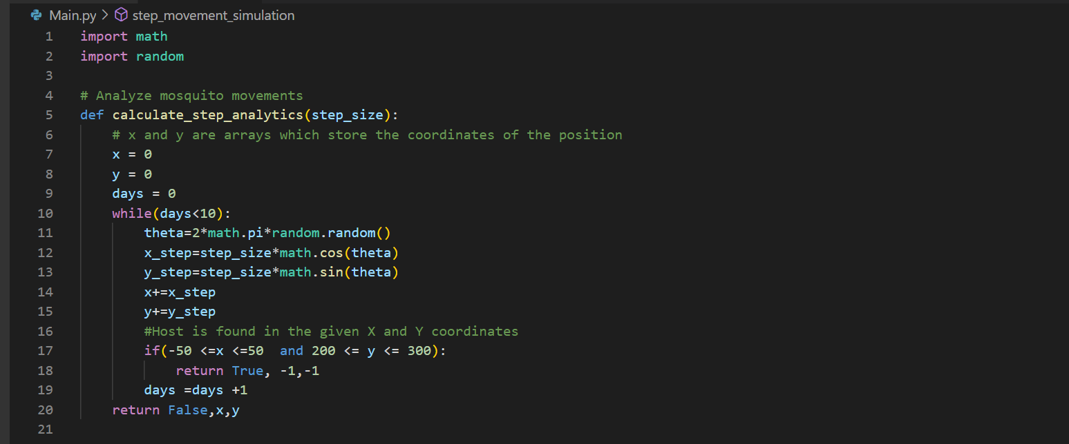

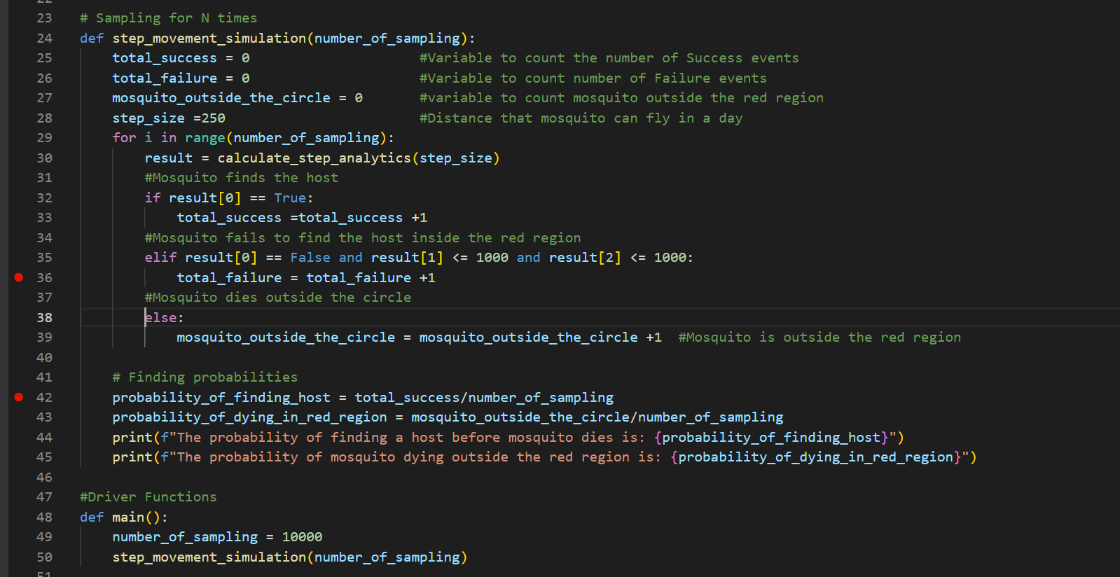

**Results of Monte Carlo Simulation:**

We have performed sampling various times to show the accuracy of the results.

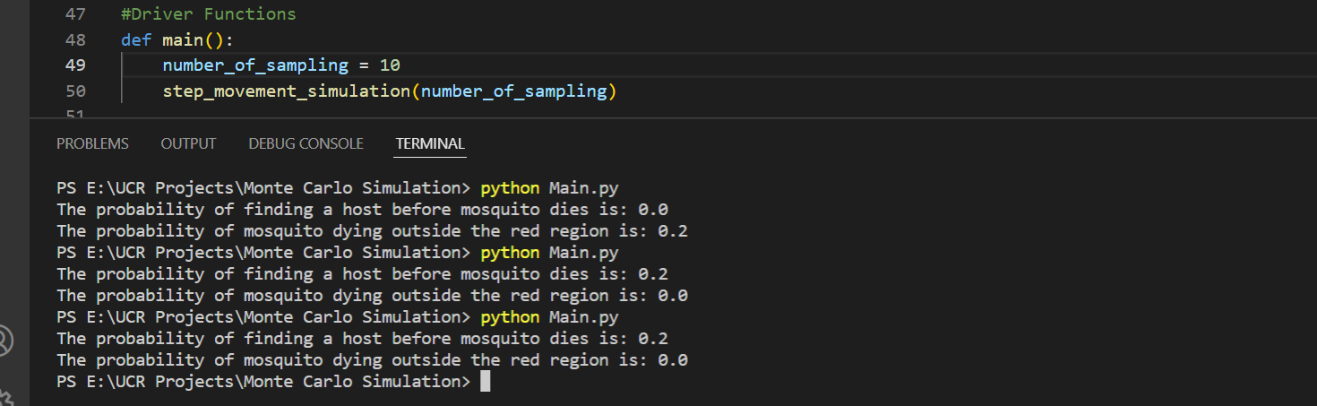

**Number of times sampling done = 10**

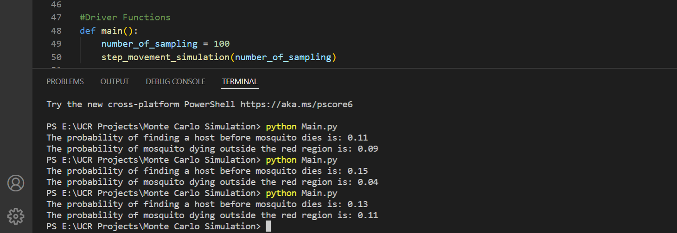

**Number of times sampling done = 100**

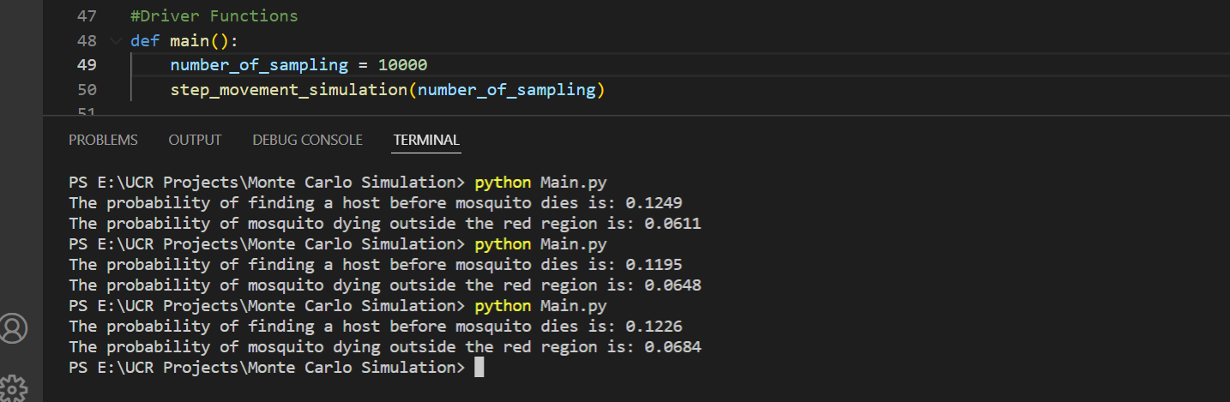

**Number of times sampling done = 10000**

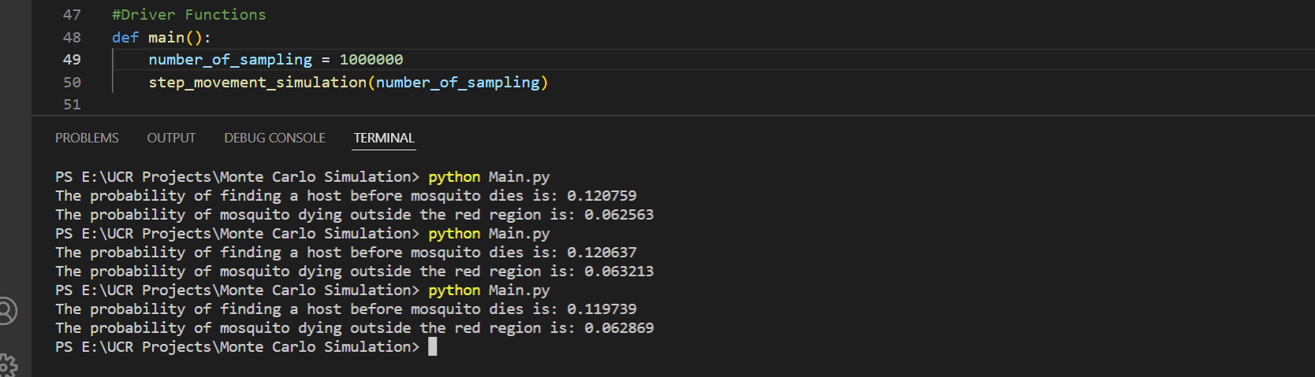

**Number of times sampling done = 1000000**

**For extra-extra credits**

**1. Suppose the mosquito lives for 100 days. Create a plot showing the probably that the insect finds the host by day K.**

For this graph, the probability of a mosquito finding the host on each particular day is calculated. We are checking the coordinates of the mosquito flying in random directions and the coordinates of the host on each particular day. If the points of the mosquito lie within the range of coordinates of the host at the end of the day, we return the days (suppose if the location is found on 10th day, return 10). Once X-axis (Number of days) and Y-axis (Probabilities on each particular day) are calculated, we built a graph using Matplotlib in python.

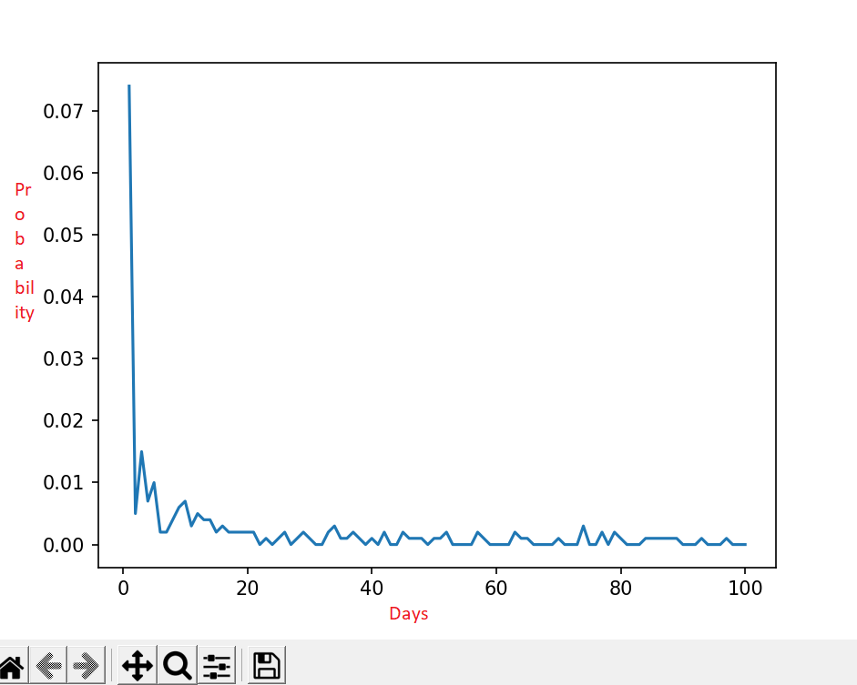

**2. In our assumption, we assume that the mosquito turns off its sense of smell as it makes a random flight. However, suppose that was not the case. That would mean that even if it flies over the yellow circle, it will find the host. Compute this probability.**

For this approach, when the mosquito is at origin, random x point and random y point are calculated using random theta generated as we did for previous problems.

Since some magic happens and now mosquitoescan sense while flying too. So, we need to take each step at a time in the calculated random direction and check the updated coordinates of whether the mosquito lies in the host region or not. If yes, count all the favorable outcomes and thus we found the probability.

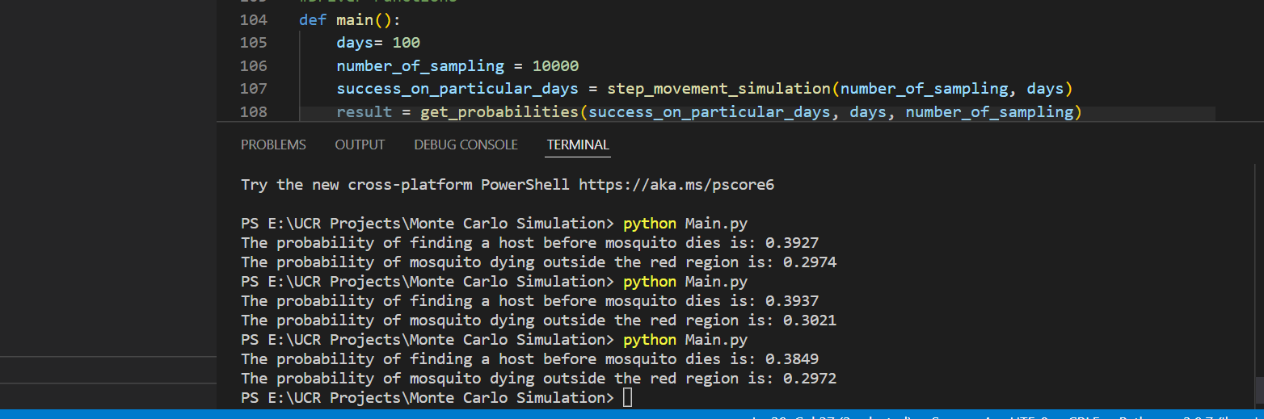

**3. Suppose that the center of the yellow circle can move along the Y-axis, form as little as zero to at most 2,525 m (at which point, the mosquito cannot reach it), and create a plot showing the probability that the (ten days) insect finds the host, as a function of K. For this case, we are assuming that mosquito can smell while flying too.**

Since for this problem, the host can move along the y-axis and thus we have generated random y-axis values from 0 to 2525. As in the above problem, we can assume that the mosquito can sense while flying too and thus we need to take each step at a time in the calculated random direction and check the updated coordinates of whether the mosquito lies in the host region or not. For this problem, the host can be within the x-axis ranging from -50 to 50 and a y-axis from any random value between 0 to 2525. The graph has been plotted with probabilities of 10 days and the random y-axis as a function of k.

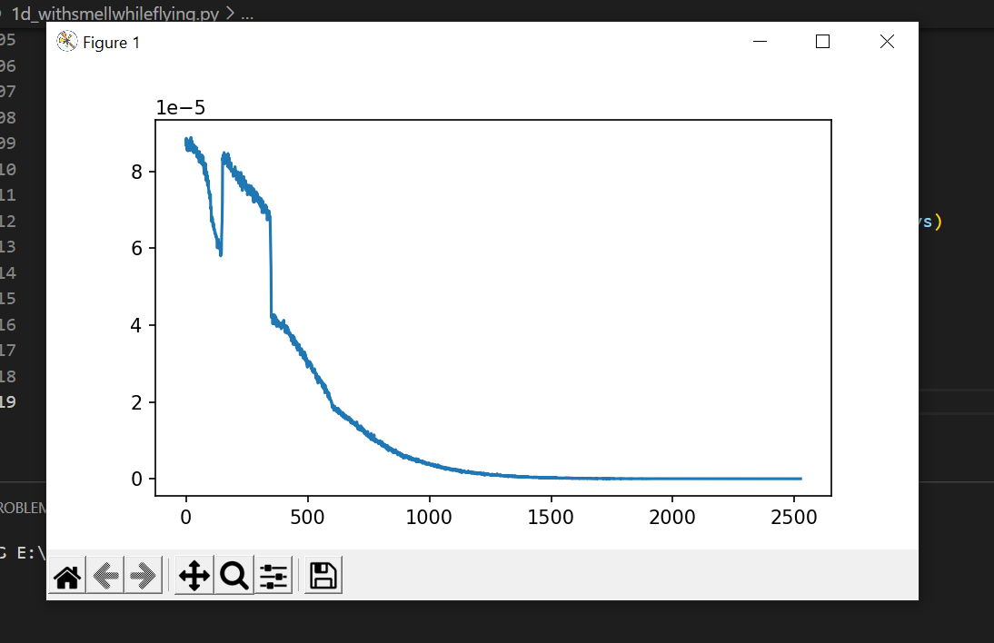

**4 Suppose that the center of the yellow circle can move along the Y-axis, form as little as zero to at most 2,525 m (at which point, the mosquito cannot reach it), and create a plot showing the probability that the (ten days) insect finds the host, as a function of K.**

**For this case, we are assuming that the mosquito cannot smell while flying. She can only smell after the flight.**

In this case, we are not incrementing the x and y points of the mosquito during the flight. We are checking the points after the completion of 250m in a random direction. The host can be within the x-axis ranging from -50 to 50 and a y-axis from any random value between 0 to 2525. The graph has been plotted with probabilities of 10 days and the random y-axis as a function of k (days).

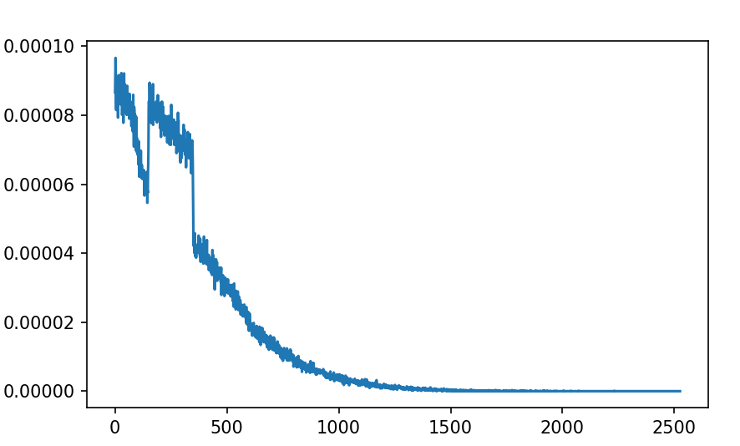

**Conclusion:**

Initially, Sampling is done 10 times and we can clearly observe that consistency of results is not too great. It even shows 0 for finding hosts sometimes.

Gradually we increased the sampling numbers and if we do with a large number, we get consistent results.

Initially, I used naïve analysis and calculate that the probability to find the hosts is **0.0025** but later with Monte Carlo Algorithms and Sampling number = 1000000, the probability was **0.1207. My initial naïve guess was very low compared to the calculated probability.**

**We also saw that the accuracy increases if the number of samplings tends to infinity.**